<https://www.fibalivestats.com/u/FUBB/1381241/st.html>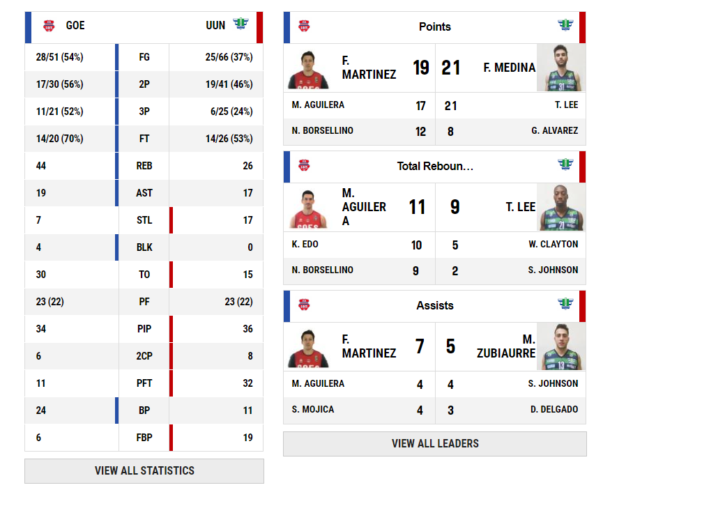 match_ids = [**'1381241'**]

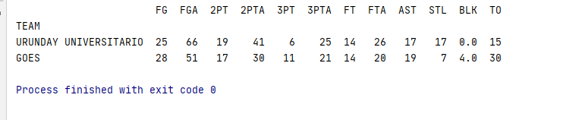

match_ids = [**'1381246'**, **'1381247'**, **'1541195'**]

1381246 – **AGUADA** -SAYAGO

1381247 – **AGUADA** -TROUVILLE

1541195 – D.SPORTING – URUNDAY

